**Installation Manual for Setting Up the Project Using Laragon**

This guide provides step-by-step instructions on how to install and set up the project using **Laragon**. Since the project is built with **HTML, CSS, JavaScript, and PHP**, Laragon will serve as a local development environment.

**Prerequisites**

Before proceeding, ensure you have the following:  
✅ Windows OS (Laragon is optimized for Windows)  
✅ Laragon installed (Download from [Laragon.org](https://laragon.org/))  
✅ A code editor (e.g., VS Code, Sublime Text, or Notepad++)

**Step 1: Download and Install Laragon**

1. **Download Laragon**
   * Visit Laragon.org and download the latest **Laragon Full** version.
2. **Install Laragon**
   * Run the downloaded installer and follow the on-screen instructions.
   * Choose a preferred installation directory (default: C:\laragon\).

**Step 2: Start Laragon and Configure It**

1. Open **Laragon** and click **Start All** to run Apache and MySQL.
2. Click the **Settings** (gear icon) and ensure:
   * Apache is enabled
   * MySQL is running (for database support)
3. Set the PHP version if required by clicking **Menu → PHP → Version** and selecting the desired version.

**Step 3: Set Up the Project Files**

1. **Locate the Laragon www Folder**
   * Navigate to C:\laragon\www\ (or the custom location you chose).
2. **Copy the Project Files**
   * Extract or copy your project folder into C:\laragon\www\.
   * Your project folder should contain files like index.php, style.css, and script.js.

**Step 4: Configure the Database (If Required)**

1. Open **Laragon** and click **Menu → MySQL → phpMyAdmin** to launch phpMyAdmin.
2. Create a new database:
   * Click **New** on the left panel.
   * Enter a database name (e.g.,rnd_website) and click **Create**.
   * Make sure database collation is utf8mb4_0900_ai_ci
   * 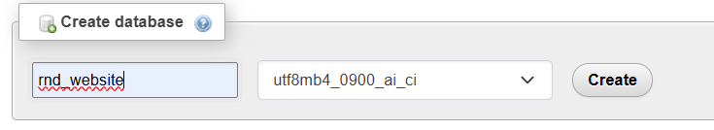
3. Import an existing database:
   * Click the database name.
   * Select **Import**, choose the .sql file, and click **Go**(it is provide in drive).
4. Update database credentials in config.php (or .env if applicable):

php

CopyEdit

$servername = "localhost";

$username = "root";

$password = ""; // No password by default in Laragon

$dbname = "project_db";

**Step 5: Run the Project**

1. Open Laragon and click **Menu → www → [Project Folder]**
2. Alternatively, open a browser and enter:

arduino

CopyEdit

http://localhost/project-folder/

1. Your project should now be live on **localhost**.

**Step 6: Troubleshooting**

* **Error: Page not found (404)**
  + Ensure the project folder is inside C:\laragon\www\.
* **Error: Database connection failed**
  + Check config.php for correct credentials.
* **Blank page**
  + Enable error reporting in config.php by adding:

php

CopyEdit

error_reporting(E_ALL);

ini_set('display_errors', 1);

**Conclusion**

You have successfully set up your PHP project using **Laragon**. You can now develop, test, and manage the project efficiently in your local environment. 🚀